5. Deal Structure
All-cash acquisition of 100% of Organon at $14.00/share. Enterprise value ~$11.75bn; equity value ~$3.64bn; ~$8.1bn of net debt assumed/refinanced. Funded by ~$2–2.5bn of Sun internal accruals and ~$9.25–9.75bn of new debt via a $12bn committed bridge (Sun Pharma USA). Net leverage ~2.3x at close. Break fee $120m. Expected close early 2027.

5.1 Transaction structure
- Form. All-cash merger; Sun (via a US acquisition vehicle, Sun Pharma USA) acquires 100% of Organon’s outstanding shares. Organon becomes a wholly owned subsidiary.
- Consideration. $14.00 per share in cash. No stock, no earn-out, no CVR — a clean cash deal (no exchange ratio or collar to model).
- Acquisition vehicle. Offshore US entity funds and holds the target — the structuring choice that drives the tax and financing treatment (Chapter 4) and sidesteps Indian outbound-financing constraints.

5.2 Purchase consideration and value bridge
Item | Value | Basis
Offer price per share | $14.00 | Disclosed
Fully diluted shares | ~260m | Inferred (adj. NI $954m ÷ EPS $3.66); confirm from proxy
Equity value | ~$3.64bn | $14.00 × shares
(+) Net debt assumed | ~$8.10bn | FY25 gross debt $8.64bn − cash $0.57bn
Enterprise value | ~$11.75bn | Disclosed
EV / FY25 Adj. EBITDA | ~6.2x | $11.75bn ÷ $1.91bn
EV / FY25 revenue | ~1.9x | $11.75bn ÷ $6.2bn
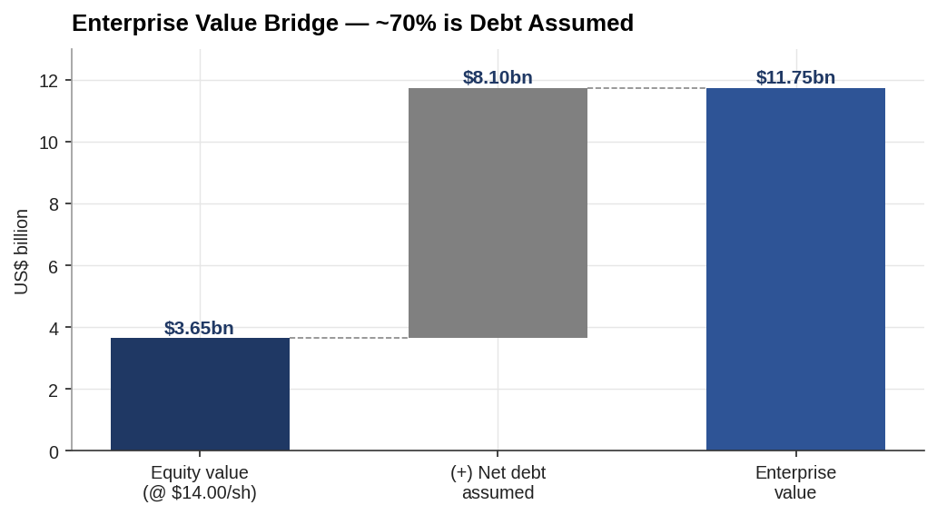
Enterprise value bridge
The bridge is the deal’s defining feature: ~$8.1bn of the ~$11.75bn (≈70%) is debt assumed, not equity purchased. The equity cheque is only ~$3.64bn.

5.3 Sources & Uses
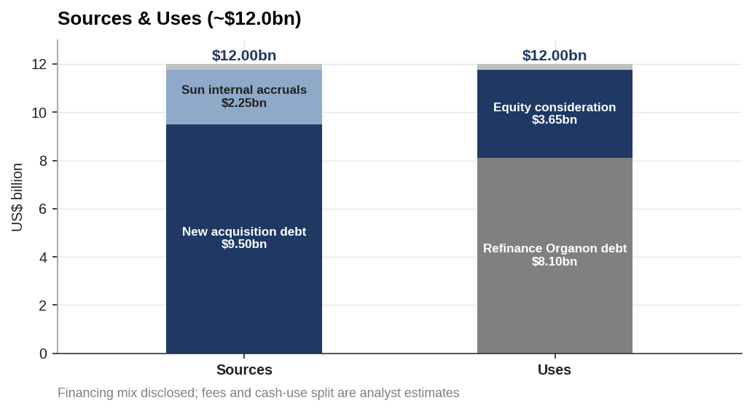
Sources and uses
Sources | $bn | Uses | $bn
New acquisition debt | 9.50 | Refinance Organon debt | 8.10
Sun internal accruals | 2.24 | Equity consideration | 3.64
Organon balance-sheet cash | 0.25 | Fees & expenses (est.) | 0.25
Total sources | 11.99 | Total uses | 11.99
Financing mix (~$2–2.5bn internal, ~$9.25–9.75bn debt) is disclosed; the fee load and cash-use split are analyst estimates, flagged.

5.4 Financing and debt
Facility | Size | Role
Committed bridge (Sun Pharma USA) | $12.0bn | Fully committed backstop to fund at close
Sun Pharma funding commitment | $1.0bn | Parent equity/inter-company support
Permanent take-out (planned) | ~$9.5bn | Term loans + bonds; euro-denominated issue, offshore loans, possible bond swaps
- Bridge-to-bond. The $12bn bridge de-risks closing; it is refinanced post-close into a permanent structure of term loans and bonds. Refinancing risk (rates/spreads between signing and take-out) is the key financing exposure — carried into the risk chapter.
- Leverage. Sun moves from ~$3.1bn net cash to ~2.3x net debt/EBITDA at close, deleveraging over 4–5 years on Organon’s cash flow.
- Currency. USD/EUR debt is partly matched by Organon’s USD/EUR cash flows; residual INR exposure at the parent.

5.5 Regulatory approvals
Approval | Jurisdiction / body | Note
Antitrust (HSR) | US FTC/DOJ | Limited product overlap eases clearance
Merger control | EU and other competition authorities | Multi-jurisdiction filings
Outbound investment | India (RBI / FEMA ODI framework) | India-outbound structuring and approvals
Shareholder approval | Organon stockholders | Simple-majority vote via merger proxy
Low direct product overlap makes antitrust the lower-risk gate; the cross-border/outbound approvals and the shareholder vote are the practical path items.

5.6 Expected timeline
- April 2026 — Definitive merger agreement signed and announced; both boards approve.
- 2026 — Organon files merger proxy (PREM14A/DEFM14A); shareholder vote; regulatory filings.
- 2026–early 2027 — Antitrust and cross-border clearances; bridge financing termed out.
- Early 2027 (expected) — Close; Organon delists and becomes a Sun subsidiary.
Deal protection. $120m termination fee payable by Organon under specified circumstances (superior-proposal / no-vote). Modest relative to the ~$3.64bn equity value (~3.3%).

5.7 Structure conclusion
A clean, all-cash, debt-funded acquisition where the real financing task is absorbing and refinancing ~$8.1bn of target debt, not paying a large equity premium. The structure is de-risked on closing (committed bridge) and on antitrust (low overlap); the live risks are the bridge take-out cost and the cross-border/shareholder approval path. This structure feeds directly into the merger model — purchase price allocation, the debt schedule, and accretion/dilution — in Chapter 8.

Assumptions & sources
- Enterprise value ($11.75bn), $14.00/share, financing split (~$2–2.5bn internal; ~$9.25–9.75bn debt), $12bn committed bridge (Sun Pharma USA), ~2.3x net leverage, and $120m break fee are disclosed.
- Share count (~260m), net debt ($8.1bn = gross $8.64bn − cash $0.57bn), fees (~$0.25bn) and the Sources & Uses split are estimates for illustration; exact figures to be tied to the merger proxy and financing documents.
- Permanent financing structure (term loans/bonds/euro issue/bond swaps) reflects disclosed intent; final tranching not yet set.
- Regulatory items reflect the deal’s jurisdictions; specific clearance conditions to be confirmed from filings.
Sources: Sun Pharma / Organon definitive-agreement press releases (Apr 2026); Sun Pharma investor commentary; Outlook Business and Business Standard on financing; Organon merger proxy (to be pulled). Full sourcing map in 05_Data/DATA_SOURCES.docx.

